ASSIGNMENT NO. 14
CHAPTER- SYMMETRY
CLASS- VII SUBJECT- MATHS

Q1. Complete the table given below:-
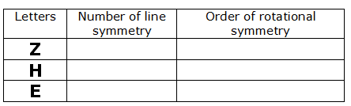
Q2. Draw a triangle with one line of symmetry and rotational symmetry of order one.

Q3. In the following diagram, Identify the line of symmetry and order of rotational
Symmetry:-
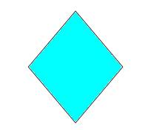
Q4. Give an example of an alphabet which has two lines of symmetry as well as
rotational symmetry of order 2.

Q5. Assuming the given line to be mirror, complete the diagram:-
