ASSIGNMENT –3 [ UNIT – 19] CLASS – V SUBJECT-MATH ROLL NO. ________
1Q. The favourite colour of 30 students is as follows :
B R P R P B R B B P
R B P P B P P R R B
B P P B R B P B P R
P→ Pink
B→ Blue
R→ Red
COLOUR | TALLY MARKS | NO. OF STUDENTS
Pink
Red
Blue
Complete the following table with above data:

2Q. The number of music systems sold in different months is as follows:
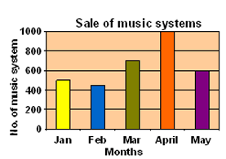
Read the above bar graph and answer the following questions:
- In which month,minimum systems were sold ?
- How many systems were sold in March ?
- In which month 500 systems were sold ?
- How many more systems were sold in March than May ?
- In which month, maximum systems were sold ?

3Q.Number of animals sold in a pet shop in a month is as below:
ANIMAL | CAT | DOG | SHEEP | RABBIT | PARROT
NO. OF ANIMALS | 40 | 70 | 20 | 50 | 30

Prepare a pictograph for above data by using symbol = 10 Animals

