ASSIGNMENT 15
CLASS:- IV CHAPTER NO. 19 SUBJECT:- MATHS
1Q.Fill ups
a) Perimeter of a square =4×_____
b) Perimeter of a rectangle=_________
c) Square and rectangles are special types of ______________.
2Q.Find the perimeter of a rectangle whose sides are 10 m and 13m.
3Q. Find the perimeter of square whose each side is 16cm.
4Q. Find the perimeter of square whose each side is 11m 25cm.
5Q.Find the area of a rectangle of sides 32 cm and 20 cm.
6Q.Find the area of a rectangle of length= 51 cm, breadth = 23
7Q. Find the perimeter of figure
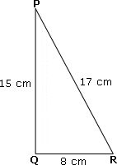
A B
5cm
C 12cm D

8Q. Write the formula of
a)Area of square
b) Perimeter of square

