ASSIGNMENT 10
CLASS :IV CHAPTER NO. 12&20 SUBJECT:-MATHS
1Q.Restaurant surveyed a sample of customers on their favorite food. They made pie graph
With the survey results. Read the pie graph and answer the questions
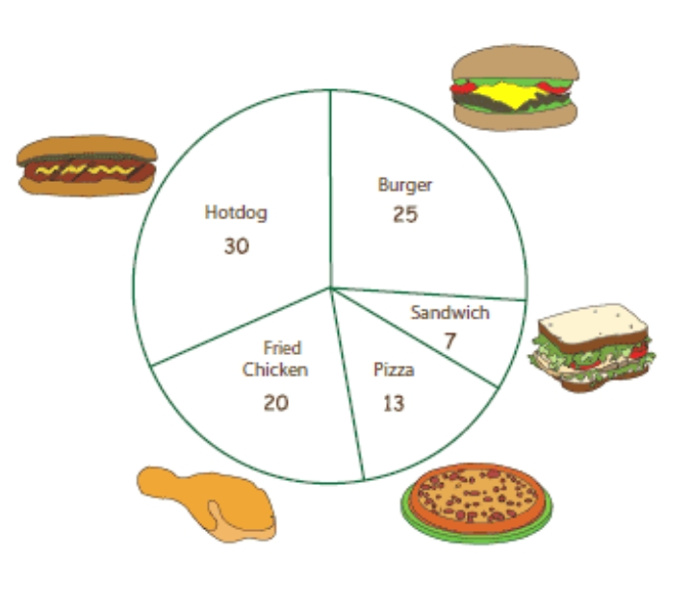
a) Which is the most favorite among the customers?
b) How many customers like fried chicken?
c) Which is the least favorite food?
d)How many customers participated in the survey?

RENT
FOOD
EDUCATION
TRANSPORT
OTHERS
=Rs.1,000
2Q.The pictograph shows how much a family spends on different things every month.
a)What does the family spend the most on ?
b)How much does it spend on transport?
c)How much does it spend in total?
3Q. 11 shirts cost Rs. 12100. Find the cost for 21 shirts?
4Q.The cost of 9 cycles is Rs. 2925. What is the cost of 1 cycle?
5Q.The cost of 5 chairs is Rs.4505.What is the cost of 9 chairs?

