MATH ASSIGNMENT--- 7
STD- 2ND ROLL NO -

Q.1 Complete the Patterns :-

a)
_____, ______, ______
b) MN OP QR ST _____, ______, ______
C) 40 50 60 70 _____, _______,______
d) 520 522 524 526 _____, _______,______
e) _____, _______,______
f) 5 10 15 20 _____, _______, _____
g) 179 178 177 176 _____, ______ , _____
Q.2 Tell the time :-
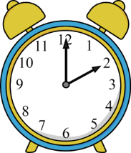 _________ 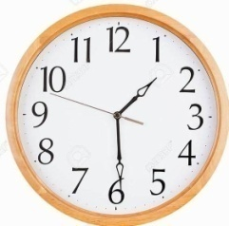_________

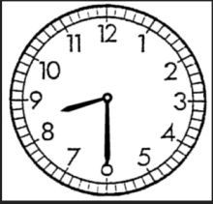 __________ 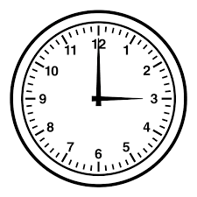 __________

Q- 3 Write the time in words.
a) 5:15 _____________________ c) 8:45 ____________________
b) 7:00 _____________________ d) 6:30____________________

