ASSIGNMENT NO.- 10[Ch-8(Application of Integrals)]
Class -XII

1. Find the area enclosed by the curve $x=3\cos{t ,y=2\sin{t}}$ 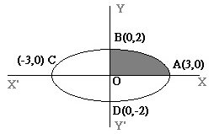
2. Find the area of the region enclosed by the parabola $x^{2}=y$ and the line $y=x+2.$ 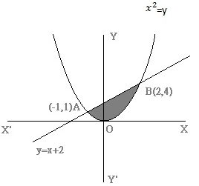
3. Find the area of the minor segment of the circle $x^{2}+y^{2}=a^{2}$ cut off by the line $x=\frac{a}{2}.$ 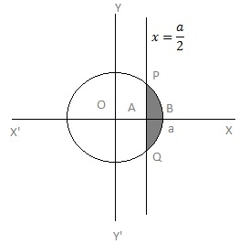
4. Using the method if integration ,find the area of triangle ABC,coordinates of whose vertices are
$A\left(2,0\right), B(4,5)$ and $C\left(6,3\right).$
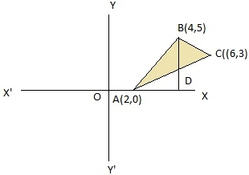
5. . Using the method if integration ,find the area of triangle ABC,coordinates of whose vertices are
$A\left(1,-2\right), B(3,5)$ and $C\left(5,2\right).$
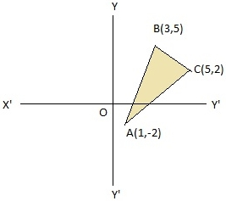
6. Find the area of the region bounded by the parabolas $y^{2}=6x$ and $x^{2}=6y.$ 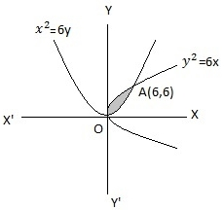
7. Find the area enclosed between the curves $y=8-x^{2}$ and $y=x^{2}$. 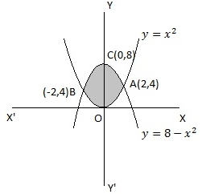
8. Find the area of the region bounded by the curves $y=x^{2}+2,y=x,x=0$ and $x=3.$ 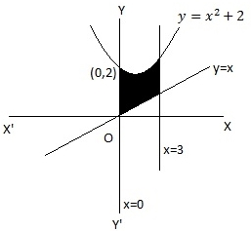
9. Using integration,find the area of the region bounded by the triangle whose vertices are
$\left(-1,2\right),B(1,5)$ and $\left(3,4\right).$ 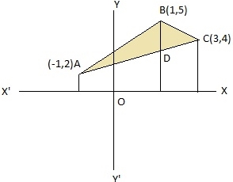
10. A farmer has a field in the form of a parabola $x^{2}=4y.$He has planted trees in the exterior to the
region bounded by the curve $y=\left|x\right|$ and left the remaining part for children to play.Find the
area of the ground,where children can play. 