ASSIGNMENT (2020-21)
CLASS - X SUBJECT – MATHEMATICS
CH- 8(INTRODUCTION TO TRIGONOMETRY)
- (sin30° + cos30°) – (sin 60° + cos60°)
(A) – 1 (B) 0 (C) 1 (D) 2
- Value of tan30°/cot60° is:
(A) 1/√2 (B) 1/√3 (C) √3 (D) 1
- The value of sin θ and cos (90° – θ)
(A) Are same (B) Are different (C) No relation (D) Information insufficient
- If cos A = 4/5, then tan A =?
(A) 3/5 (B) 3/4 (C) 4/3 (D) 4/5
- The value of the expression [cosec (75° + θ) – sec (15° - θ) – tan (55° + θ) + cot (35° - θ)] is
(A) 1 (B) −1 (C) 0 (D) 1/2
- If sin θ + sin² θ = 1, find cos⁴ θ + cos² θ
- In XYZ, ∠X = 90°, ∠Z = 45° If XY = 12 cm find YZ and XZ.
- Prove that : (sin⁶ θ + cos⁶ θ) = 1 – 3 sin² θ cos² θ
- Prove that :
- tan x= sin 45°cos45°+sin 30°, Find x.

- Prove that : 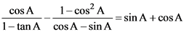
- Find value of 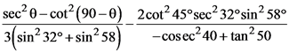
- Prove that : 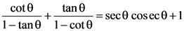
- If cot²θ = 1 – a² prove that cosec θ + cot³θ secθ = (2 – a²)^{3/2}
- If cosec θ + cotθ = p, then show that 