ASSIGNMENT (2020-21)
CLASS - X SUBJECT – MATHEMATICS CH- 6(TRIANGLES)
- If S is a point on side PQ of a $∆PQR$ such that PS = QS = RS, Then
$\left(a\right)$ $PR.QR={RS}^{2}$ $\left(b\right)$ ${QS}^{2}+{RS}^{2}={QR}^{2}$ $\left(c\right)$ ${PR}^{2}+{QR}^{2}={PQ}^{2}$ $\left(d\right)$ ${PS}^{2}+{RS}^{2}={PR}^{2}$
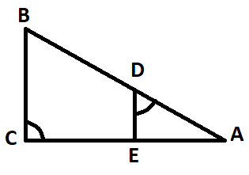
- It is given that $∆ABC \sim ∆DFE, ∠A=30°, ∠C=50°, AB=5 cm, AC=8 cm and DF=7.5 cm.$Then the following is true:
$\left(a\right)$ $DE=12cm, ∠F=50° \left(b\right) DE=12cm, ∠F=100°$
$\left(c\right) EF=12cm, ∠D=100° \left(d\right) EF=12 cm, ∠D=30°$
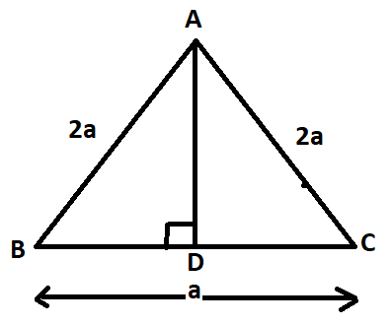
- In $∆ABC,$if $\frac{AD}{AE}=\frac{BD}{EC}$ and $∠ADE=∠ACB, then ∆ABC is:$
$\left(a\right)$ Isosceles Triangle $\left(b\right)$ Right angle Triangle
$\left(c\right)$ Equilateral Triangle $\left(d\right)$ Scalene Triangle
- In fig, value of AD is:
$\left(a\right)$ $a\sqrt{15 }unit \left(b\right) a^{2}\sqrt{15} unit \left(c\right) \frac{a\sqrt{15}}{2} unit \left(d\right) \frac{a\sqrt{15}}{3} unit$
- The length of the diagonals of a rhombus are 24 cm and 32 cm. the perimeter of the rhombus is :
$\left(a\right)$ 9 cm $\left(b\right)$ 128 cm $\left(c\right)$ 80 cm $\left(d\right)$ 56 cm
- In the given fig, $DB⊥BC, DE⊥AB and AC⊥BC, Prove that: \frac{BE}{DE}=\frac{AC}{BC}$
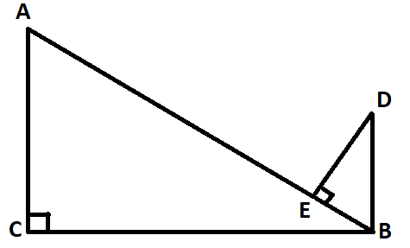

- In quadrilateral ABCD, $∠B=90°, If {AD}^{2}={AB}^{2}+{BC}^{2}+{CD}^{2}, prove that ∠ACD=90°$
- Though M the mid- point of side CD of a parallelogram ABCD, the line BM is drawn intersecting AC at L and AD produced at E. prove that EL = 2BL.
- In $∆ABC,D$ is mid point of side BC and $AE⊥BC. If AC>AB$, Show that: ${AC}^{2}={AD}^{2}+{\left(\frac{BC}{2}\right)}^{2}+BC.DE$
- In $∆ABC$, Let P and Q be points on AB and AC respectively, such that $PQ∥BC$. Prove that the median AD bisects PQ.
- Prove that in any triangle, the sum of the square of any two sides is equal to twice the square of the median which bisect the third side.
- The ration between the areas of the similar triangles is 16 : 25, find the ratio between their:
(a) Perimeter (b) Altitude (c) Medians
- The sides of a triangle ABC are in the ratio AB : BC : CA = 1 : $\sqrt{2}$ : 1. Show that triangle ABC is a right triangle, right angled at A.
- Prove that any line parallel to parallel sides of a trapezium divides the non-parallel sides proportionally.
- In the figure, $DE∥BC$ and $AD=4x-3, AE=8x-7, BD=3x-1 and CE=5x-3, find x.$
