ASSIGNMENT (2020-21)
CLASS - X SUBJECT – MATHEMATICS
CH- 10 (CIRCLES)
- In the given figure, PT is a tangent to the circle and O is its centre. Find OP.
(a) 16 cm (b) 15 cm (c) 18 cm (d) 17 cm
- In the figure, Ab is a chord of length 16 cm, of a circle of radius 10 cm. The tangents at A and B intersect at a point P. Find the length of PA.
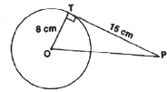
(a) (b) (c) (d)
- In the given figure, PA and PB are tangents from P to a circle with centre O. If ∠AOB = 130°, then find ∠APB.
(a) 40° (b) 55° (c) 50° (d) 60°
- In the given figure, PT is a tangent to a circle whose centre is O. If PT = 12 cm and PO = 13 cm then find teh radius of the circle.
(a) 5 cm (b) 4 cm (c) 6 cm (d) 4.5 cm
- In the figure, if Ab = AC, prove that BE = CE.
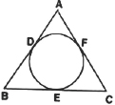
- PQ is a chord of length 8 cm of a circle of radius 5 cm. The tangents at P and Q intersect at a point T. Find the length of TP.
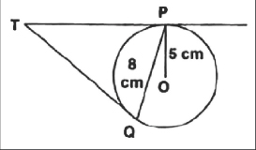
- In the figure, CP and CQ are tangents to a circle with centre O. ARB is another tangent touching the circle at R. If QC = 11 cm, BC = 7 cm then find, teh length of BR.
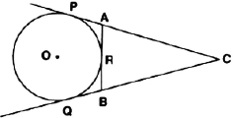
- The two tangents from an external point P to a circle with centre O are PA and PB. If ∠APB = 70°, then what is the value of ∠AOB?
- A circle is touching the side BC of a $∆$ABC at P and touchign AB and AC produced at Q and R. Prove that:
- In the following figure, OP is equal to diameter of the circle. Prove that ABP is an equilateral triangle.

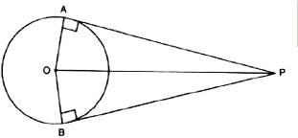
- Prove that the tangents drawn at the ends of a chord of a cricle make equal angles with the chord.
- In the figure, two circles with centres A and B and radii 5 cm and 3 cm touching each other internally. If the perpendicular bisector of segment AB, meets the bigger circle at P and Q, find the length of PQ.
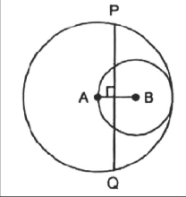
- In the following figure, two circle touch each other externally at C. Prove that the common tangent at C bisects the other two common tangents.
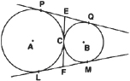
- In the figure, $∆$ABC is circumscribing a circle. Find the length of BC.
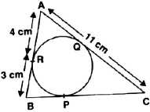
- In the figure, PA is a tangent from an external point P to a circle with centre O. If ∠POB = 115° then find ∠APO.
