STD1ST ASSIGNMENTS NO 7 ROLL NO -------

Q1 Draw the hands in given clock

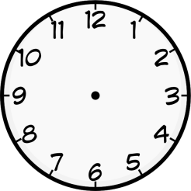    

5:00 8:00 3:00 6:00 10:00

    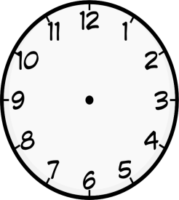

4:30 7:30 9:30 11:30 6:60

Q2 Tell the time



   